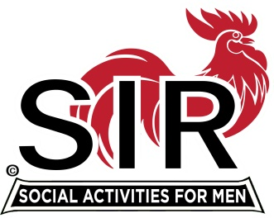
Las Trampas Branch 116
BEC Meeting Agenda
August 16, 2021, 8:30 AM via Zoom
[Zoom login at the bottom of the agenda]
The Mission of SIR is to enhance the lives of our members through fun activities, events and luncheons – while making friends for life.

8:30 am Call to order; Secretary confirm a quorum
8:35 Secretary –Paul Ramacciotti – Approval of July 19, 2021 and August 6, 2021 BEC meeting minutes
8:40 Treasurer –/Alan Fitzgerald – Report
8:45 Standing Reports
- Membership – Phil Goff
- RAMP Department Head Reports:
- Recruitment
- Activity Coordinator
- Member relations
- Publicity
- Covid Compliance [Kevin Donahue]

9:00 Big SIR Report – Sam Beret
- August 16 monthly meeting agenda
2. New mask policy and indoor branch activities [bridge, Mexican train, book club,…]
3. Nominating Committee - August 16, Election of Officers and Directors
4. Warriors Zoom meeting w/SIRs - October

9:15 Little SIR Report - Fred Wachowicz
1. Speaker
2. Birthday Boys
3. Diversity Team Report

9:25 Old Business
New Business

9:30 Adjourn; Next BEC Meeting, September 20, 2021

Join SIR Br. 116 Zoom Meeting

https://us02web.zoom.us/j/89269854543

Meeting ID: 892 6985 4543
Passcode: 826904

Dial-in: (669) 900-9128

